**Name: Roma Shirodkar Div: D15B Roll No: 58**

**Practical Manual on Terraform**

Terraform is an infrastructure as code (IaC) tool that allows you to build, change, and version infrastructure safely and efficiently. This includes low-level components such as compute instances, storage, and networking, as well as high level components such as DNS entries, SaaS features, etc.

Terraform can manage infrastructure on multiple cloud platforms. Terraform's state allows you to track resource changes throughout your deployments. You can commit your configurations to version control to safely collaborate on infrastructure. Terraform plugins called providers let Terraform interact with cloud platform and other services via their application programming interfaces (APIs).

**A) Installation and Configuration of Terraform in Windows Step 1: Download terraform**

To install Terraform, First Download the Terraform Cli Utility for windows from terraforms official website

**website:https://www.terraform.io/downloads.html**

Select the Operating System Windows followed by either 32bit or 64 bit based on your OS type.

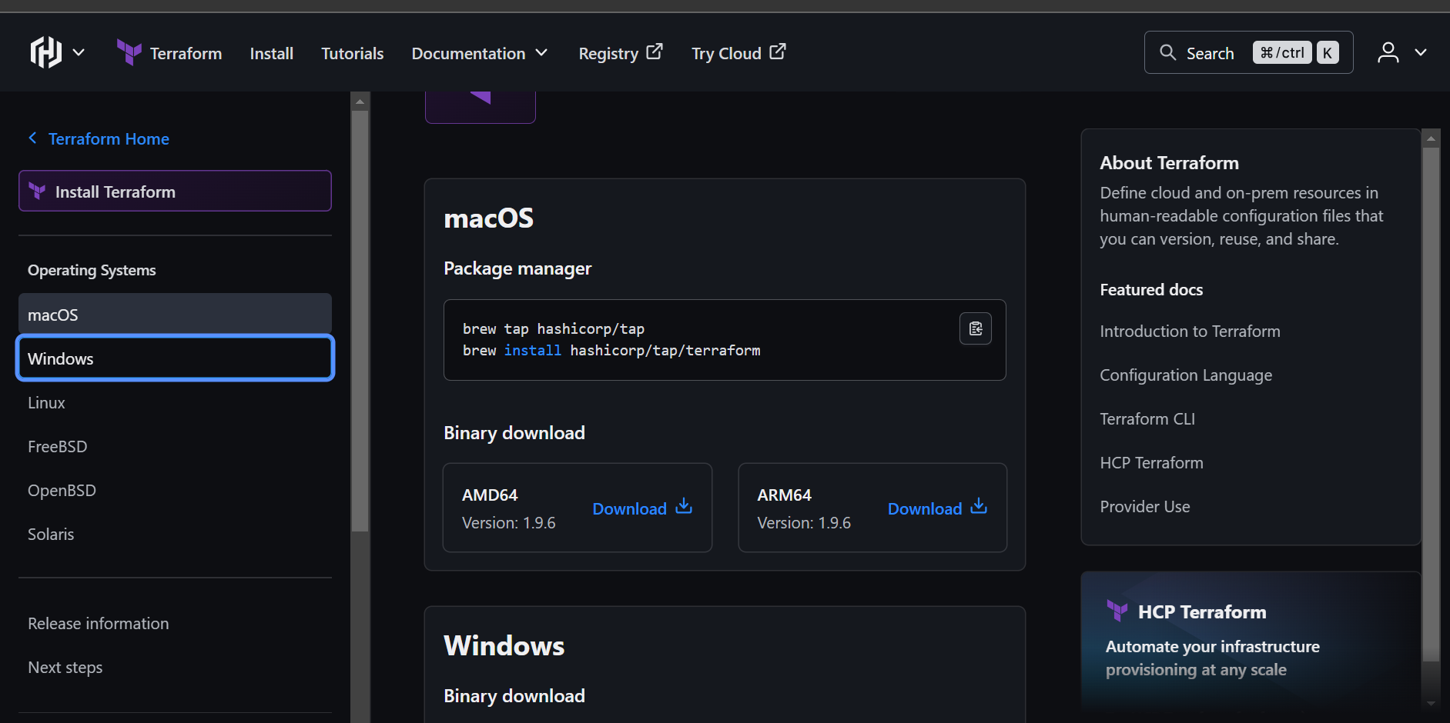

**Step 2:** Extract the downloaded setup file Terraform.exe in C:\Terraform directory

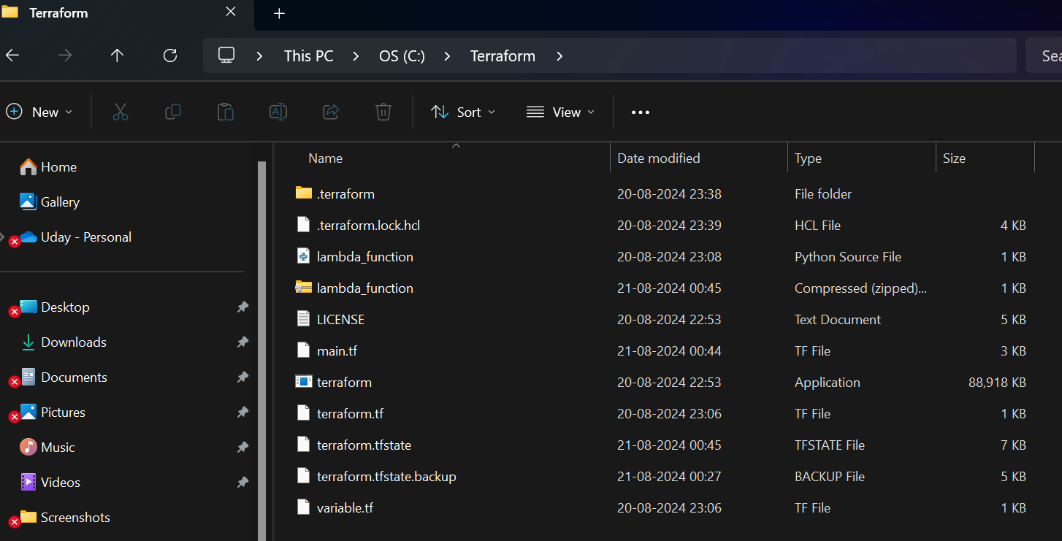**Step 3:** Set the System path for Terraform in Environment Variables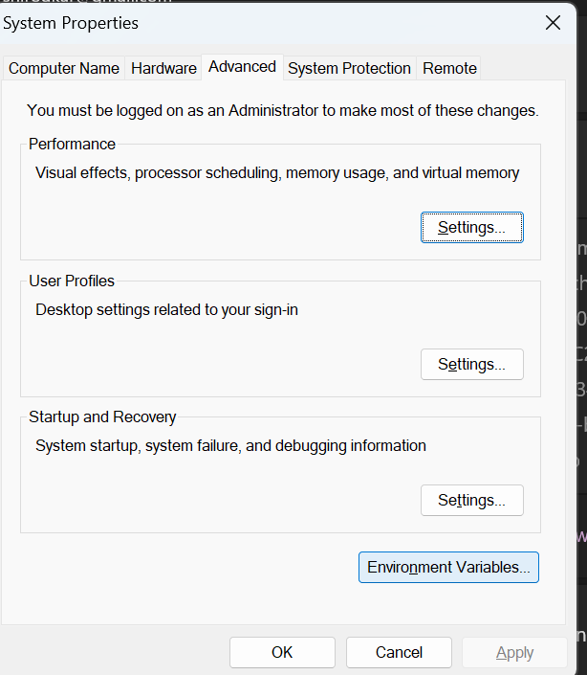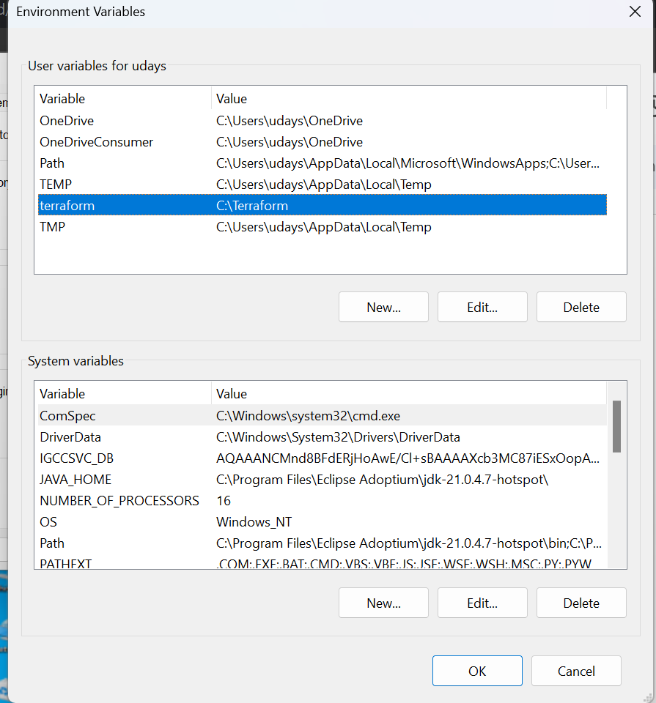

**Step 4: Open PowerShell with Admin Access**

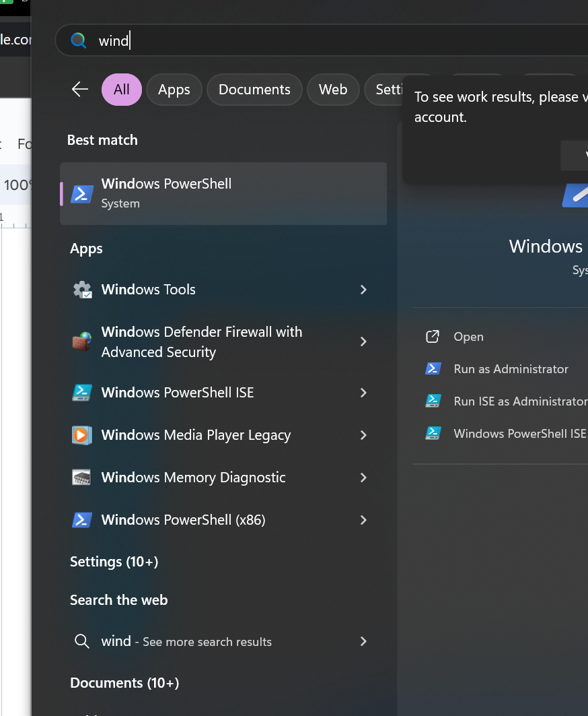

**Step 5 : Open Terraform in PowerShell and check its functionality** 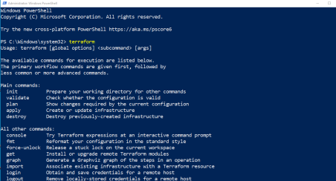

Note: If any error comes, then please recheck or set the path of Terraform in Environment variable again.

Conclusion: Thus we learnt about terraform and installed it on our system.